Change Leadership in Higher Education by Jeffrey L. Buller (2015)
The 5 Practices of Exemplary Leadership (The Leadership Challenge by Jim Kouzes & Barry Posner, 2017)
Connections

Analysis Tools (Buller, 2015) | The Leadership Challenge (Kouzes & Posner, 2017)
10 Analytical Lenses (Buller, 2015)
20/20 Lens
Concave Lens
Convex Lens
Telephoto Lens
Bifocal Lens
Rose-Colored Glasses Lens
Sunglasses Lens
Rearview Mirror Lens
Contact Lens
Wide-Angle Lens
STEEPLED Analysis (Cadle, Paul, & Turner, 2010)
Social Drivers
Technological Drivers
Economic Drivers
Ecological Drivers
Political Drivers
Legislative Drivers
Ethical Drivers
Demographic Drivers

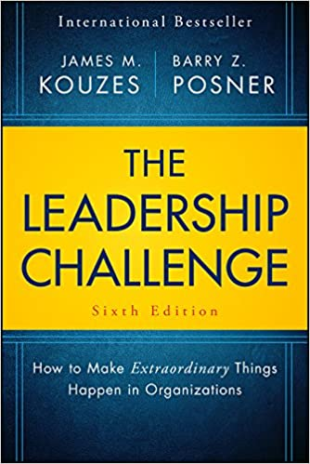

Learning Culture Theory (Schein, 2010)
These Organizations are proactive.
They are genuinely committed to learning.
They make positive assumptions about their stakeholders.
They believe that change is possible, not just in themselves but also in the larger environment.
They understand that learning methods need to change over time.
They are optimistic about the future.
They are committed to diversity.
They adopt systems approaches wherever possible.
They believe that the study of their own organizational culture is important to their growth & development.
Strategic Compass (Buller, 2015)
Step 1: What do we do best?
Step 2: What do our strengths tell us about who we really are?
Step 3: What does this identify tell us about where we should direct our resources?
Step 4: How do we develop a culture of innovation that extends but does not alter this identity?

