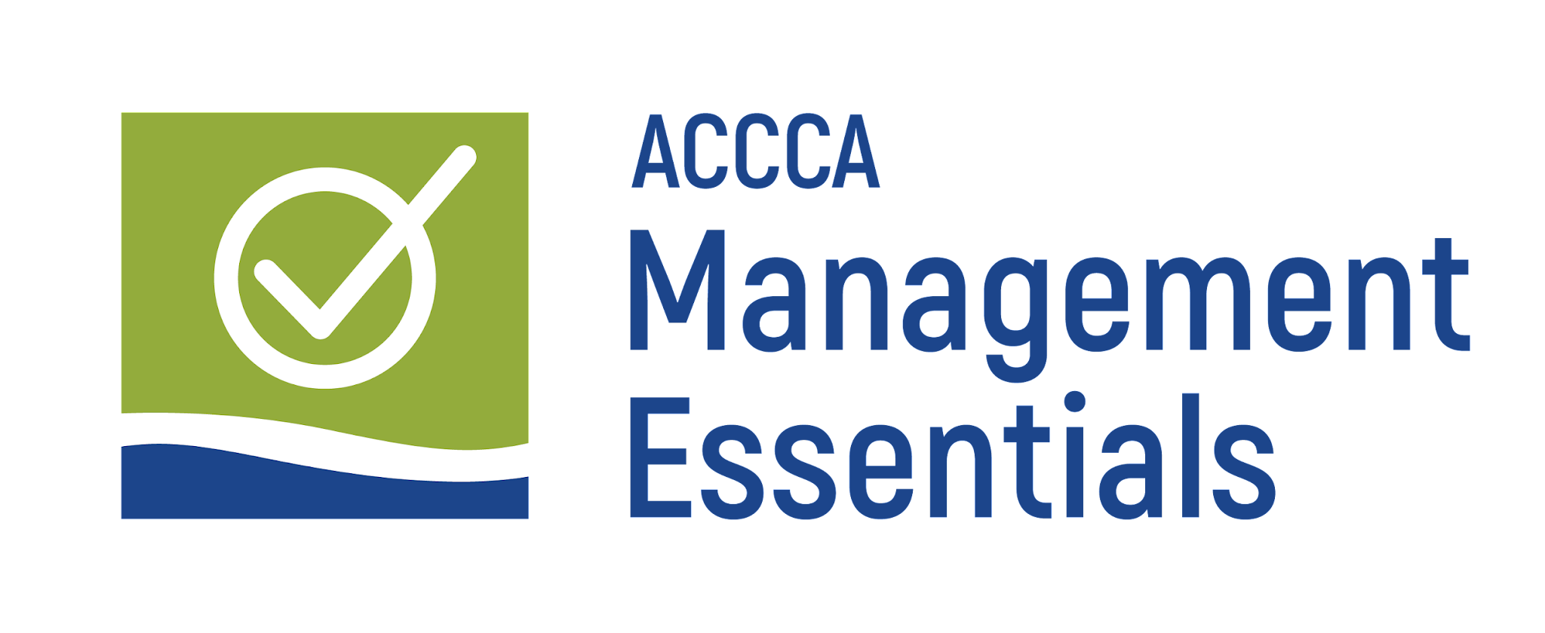

September 18, 2026
American River College
4700 College Oak Drive, Sacramento, CA 95841

8:00 am – 8:30 am Breakfast and Mingle

8:30 am – 9:15 am Land Acknowledgment, Welcome Remarks & Introductions
- Dr. David Miramontes-Quiñones, VP, Student Services & Equity, American River College
- Dr. Lisa Cardoza, President, America River College
- Dr. Claudia Lourido-Habib, Executive Director, ACCCA
- Kuldeep Kaur, President, ACCCA Board of Directors
- Lucy Alvarez, VP, Human Resources, Gavilan College

9:15 am – 10:30 am Session #1: Organizational Leadership: The Art of Motivation, Influence, and Leading with Your Roots
- Dr. Lisa Cardoza, President, America River College
- Dr. David Miramontes-Quiñones, VP, Student Services & Equity, American River College

10:30 am – 10:45 am Break

10:45 am – 12:00 pm Session #2: Institutionalizing Change: Best Practices to Implement DEIAA Initiatives
- Dr. Torence Powell, Chancellor, Los Rios CCD

12:00 pm – 1:00 pm Networking Lunch

1:00 pm – 2:15 pm Session #3: Employee Discipline & Legal Considerations
- Eileen O’Hare-Anderson, Partner, Liebert Cassidy Whitmore

2:15 pm – 2:30 pm Break

2:30 pm – 3:45 pm Session #4: Overcoming Adversity as an Administrator
- Dr. Claudia Lourido-Habib, Executive Director, ACCCA

3:45 pm – 4:15 pm Raffle prizes, takeaways, and closing remarks
- Dr. Natalie Schonfeld, Dean, Counseling & Enrollment Services, Coastline College

